All Classification models needs to be checked if the model predicts the data in wrong way(FP) or is model missed any prediction(FN), this can be checked with the help of confusion matrix.
CONFUSION MATRIX:
For classification confusion matrix are helps to find the TP, TN, FP, FN, left side table is the confusion matrix for some classification problem let as assume it is a corona prediction.
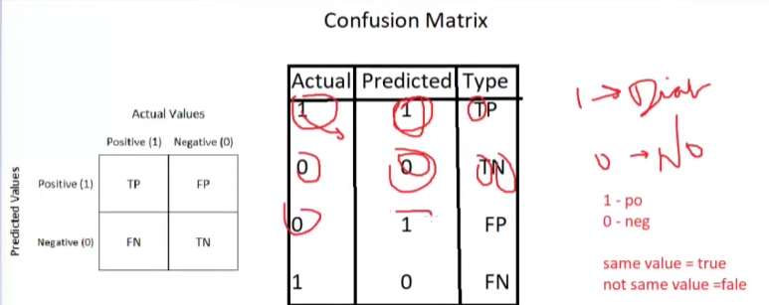

A good classification model should not have FP, FN. These can be grab by the precision(helps to reduce FP) and recall(helps to reduce FN). If we want to reduce both FP,FN then we can use F1 Score.
NOTE: The values of precision will increase when recall gets decrease, And the value of recall will increase when precision will decrease.

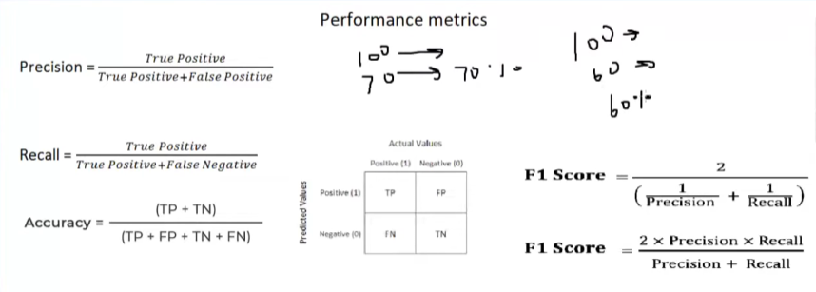
EXAMPLE FOR RECALL:
In below example the answer for recall is 0.5 that describes model can predicts only 50% percentage of data. In the below diabetes case scenario our model needs to predict all patient’s correct info. So here we have to decrease the skipped predictions by model
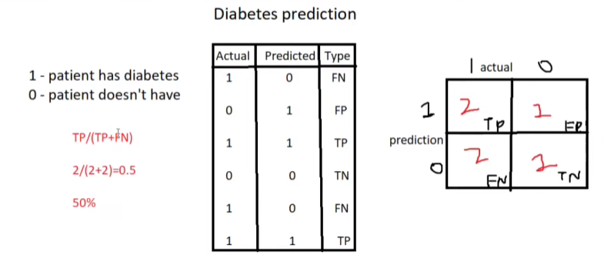

EXAMPLE FOR PRECISION:
Model predicts most of the mail are spam, but when we calculate precision we can know that only 33% of email is spam. In below scenario non spam emails are predicted as span, that is not correct so we use precision.
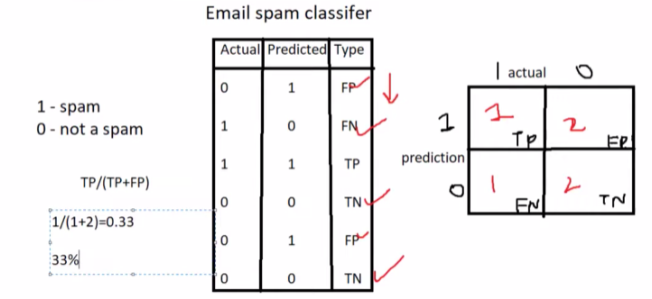
EXAMPLE FOR F1
